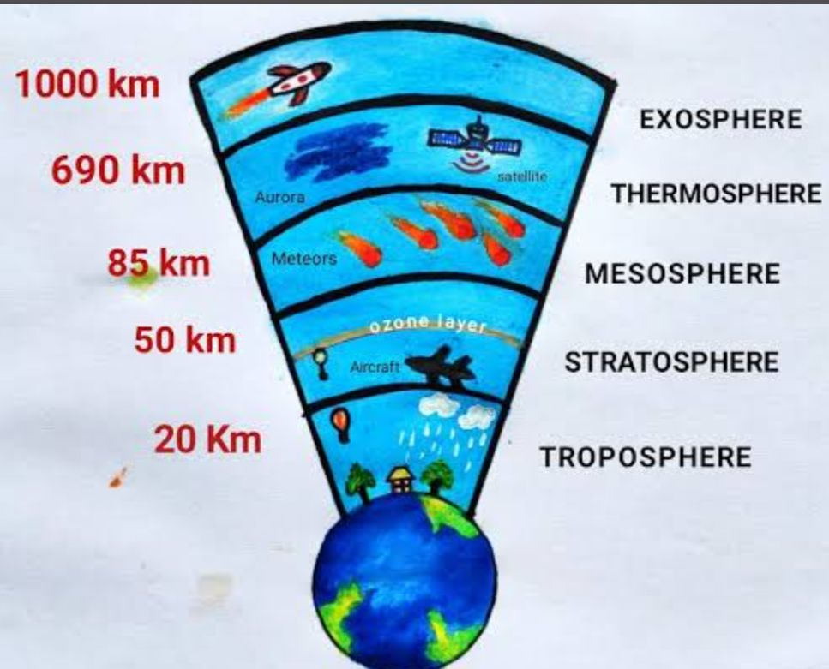
4.
• Troposphere – The lowest layer where all weather changes occur and life exists.
• Stratosphere – Contains the ozone layer that protects us from harmful UV rays.
• Mesosphere – Burns up most meteors before they reach Earth.
• Thermosphere – Helps in radio communication and contains the auroras.
• Exosphere – The outermost layer where satellites orbit the Earth.

5 . Describe the International Space Station (ISS).
A: The International Space Station is a large spacecraft where astronauts live and work in space. It moves around the Earth and is used for space research and experiments.

6. Mention some problems faced by astronauts in space due to the absence of gravity.
A: Without gravity, astronauts face difficulty in doing daily tasks. They have to strap themselves while sleeping or eating. Liquids float in the air, and they must be careful not to lose objects, as everything floats around.

